**University of Toronto**

**Faculty of Applied Science and Engineering**

**APS112**

***Project Requirements (PR)***

|  |  |  |  |
| --- | --- | --- | --- |
| Project # | 095 | Date | Feb 16th, 2023 |

|  |  |
| --- | --- |
| Project Title | Sussex Clubhouse Space Audit |
| Client | Alyssa Ahmed |
| Client Contact Person | Chris Yip |
| Tutorial Section | TUT-0114 |
| Teaching Assistant | Graeme Aylward |
| Communication Instructor | Emily Anglin |
| Engineering Manager | Konstantinos Plataniotis |
| Prepared By  (Names and Student #s of Team Members) | Matthew Ting  Dora Lyu  Margaret Chen  Anjali Jammulamadaka  Lydia Messiha  Chris Yip |
| AI Usage? (Y/N) | N |

State your document word count: _1616_ words (word count excludes Cover Page, Executive Summary, Reference List and Appendices)

Please check off which components you are submitting for your assignment.

__ PR submitted as a PDF to Quercus with the following components:

_X_ Cover Page

_X_ Executive Summary

_X_ Introduction

_X_ Problem Statement

_X_ Service Environment

_X_ Stakeholders

_X_ Detailed Requirements (FOCs)

_X_ Conclusion

_X_ Reference list

_X_ Appendices

_X_ Attribution Table

Executive Summary

Alyssa Ahmed, the coordinator of Student Life at the University of Toronto’s Sussex Clubhouse has expressed several concerns to our team about the building’s current arrangement. People are not able to move around the building efficiently, there is a decrease in students that visit the clubhouse as a result of the pandemic, and the design does not have an efficient storage system. The goal of this project is to find a solution that must fit these needs. To assess the validity of the solutions, a list of quantified objective goals and constraint limits can juxtapose each solution to determine the design that best satisfies the client’s needs.

Objectives:

* Maximize utilization of space: Ensure that the space is being used efficiently to bring in more students
* Adaptable furniture: Furniture that is easy to maneuver and can tend to each club's needs
* Durable and Robust: Design should withstand different materials, equipment, and people
* Minimize cost: Expenses should remain under $10,000
* Secure: Storage should have a safe security system
* Flexible: Storage is adaptable and can change according to club needs

Constraints:

* Must not continue renovations after the allotted time frame
* Must not reach a maximum capacity of 20 people
* Must not deconstruct room confinements (walls, windows, doors)
* Must not conflict with room designs initiated by the club

In addition to the criteria set by the client, multiple constraints are set by the environment that is crucial for designing the solution. Information on the site’s environment can help the designers understand the physical setting to which the design will respond.A list of important stakeholder populations must be considered as the design does not only impact the users. The design must additionally align with the stakeholders' needs in the design process.

This document requires additional client and stakeholder input on the specific needs to be met when designing. This will help lead the team to generate ideas to tackle the main problems of the Sussex Clubhouse. This document will propel the team forward in developing a process to meet the client's requests.

1.0.0 Introduction

21 Sussex Ave, located in Toronto ON, is an establishment that houses 50 student groups on the 4th, 5th, and 6th floors. This building also serves as an office space for the St.George Campus Safety Special Constable Service [1] and the University of Toronto’s Student Newspaper, the Varsity [2]. Alyssa Ahmed, the student life coordinator, requests to reassess and remodel the building’s 4th, 5th, and 6th floors [3] to better suit the student’s needs.

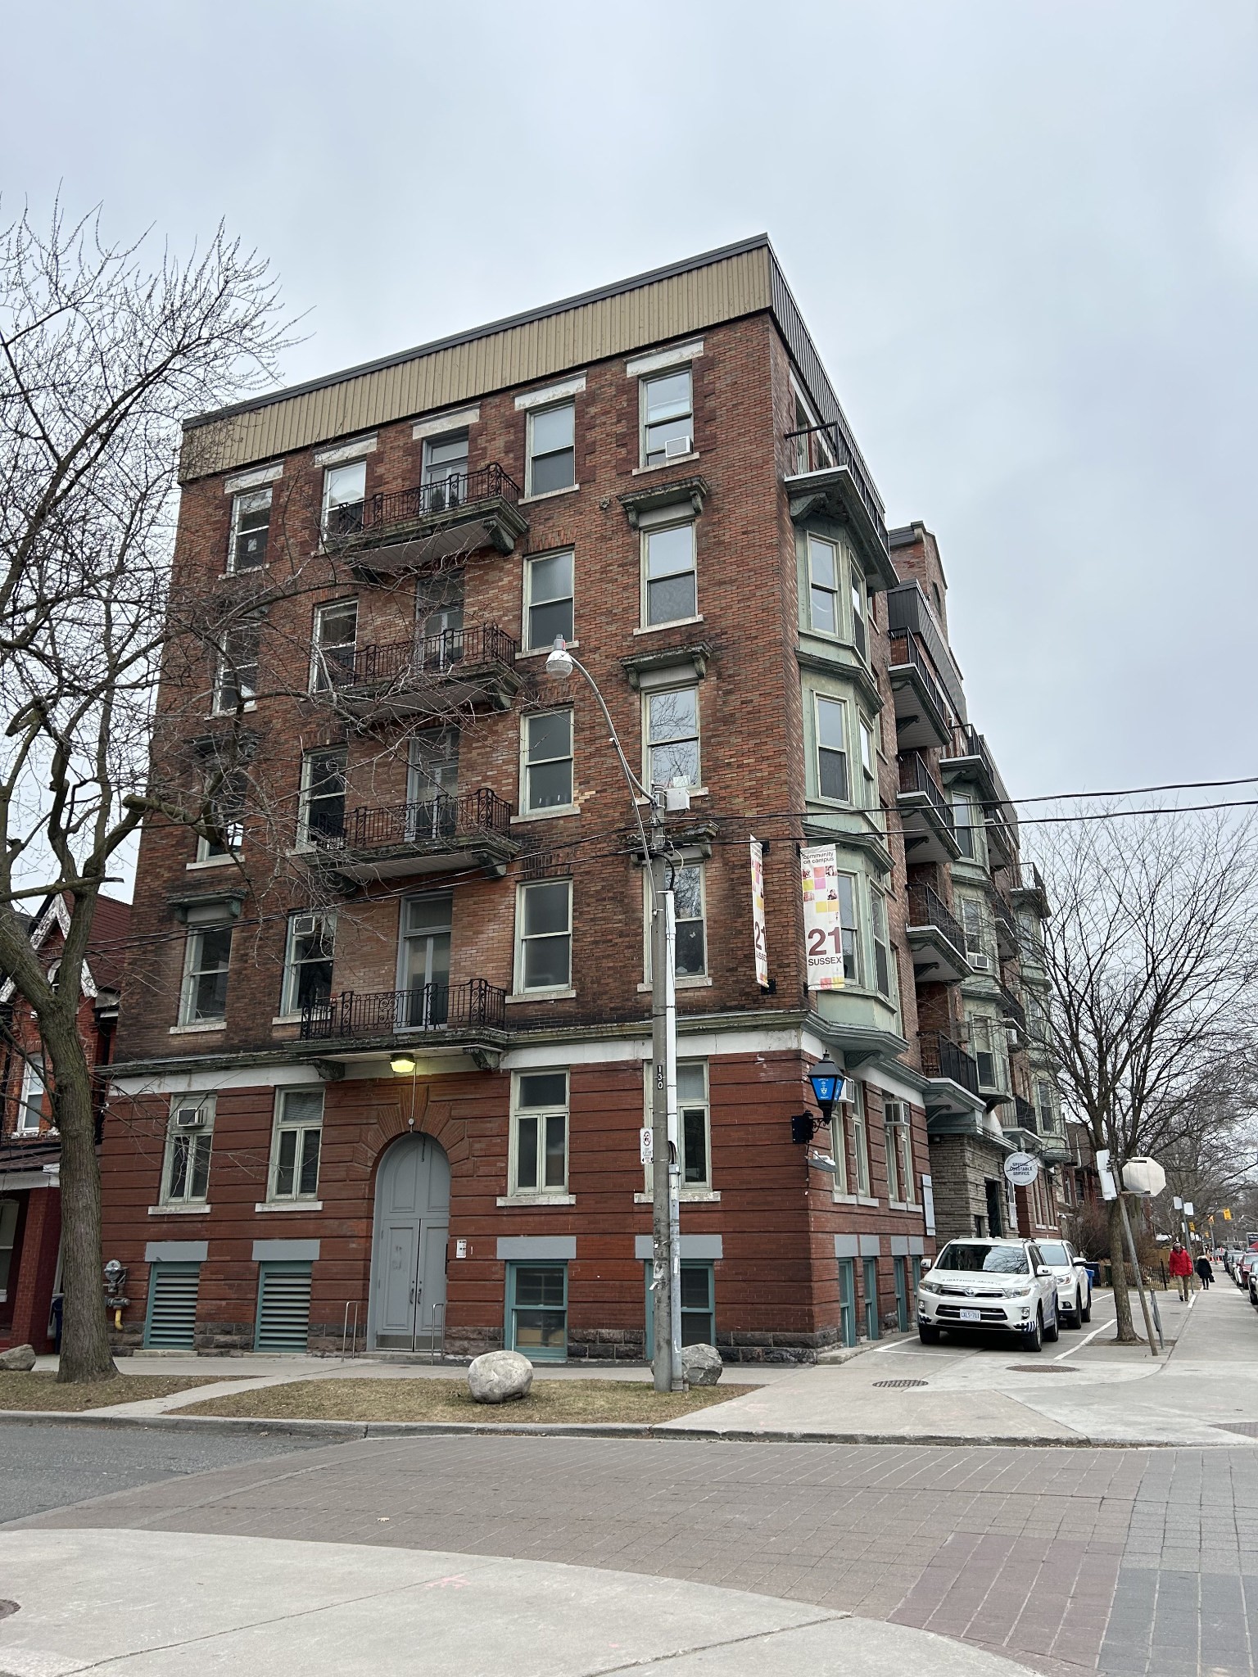

Figure 1: *Exterior of the Sussex Clubhouse*

2.0.0 Problem Statement

The problem to be addressed around the Sussex Clubhouse is the deficiency in the layout of the space which poses a significant hindrance to students coming to the Clubhouse. The current layout of the Clubhouse consists of small meeting rooms that do not have proper storage within them resulting in the space being used for storage, as shown in Figure 2. It is difficult to move around the rooms and discourages more students from visiting the Clubhouse to build a community.

The client needs an environment for student collaboration and a lively community to foster growth and creativity while also providing an efficient storage solution that caters to the needs of the users. The Clubhouse needs a reassessment of the current space andhow the students use the amenities**.**

The redesign covers the 4th to 6th floors of the Clubhouse building and has been scoped to general meeting rooms, club rooms, and storage areas. The engineering team is required to come up with efficient solutions to give students more space for club-related storage while maximizing the club room space for meetings and social events.

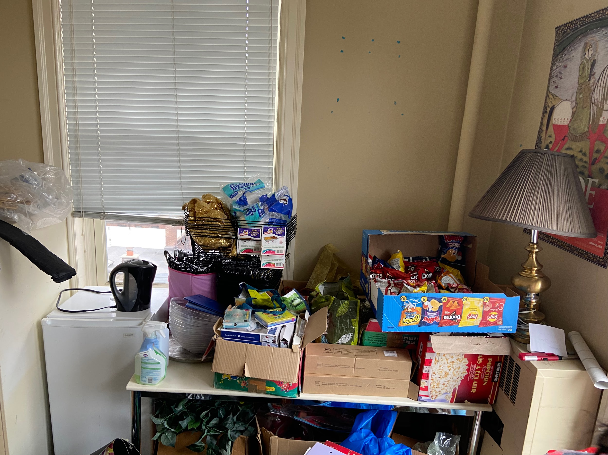

Figure 2: *Existing storage situation (using the desk as storage)*

3.0.0 Service Environment

This section provides an overview of the environment within the Sussex Clubhouse, offering insights into the environmental conditions of the room sizes, area distribution, aging facilities, and storage capabilities.

# *3.1.0* *Physical Environment*

The following table describes the diagram and metrics of the building measurements.

Table 1. *The physical environment with diagrams and metrics*

|  |  |
| --- | --- |
| **Diagrams** | **Metrics** |
| See Appendix F for floor plans of the 4th, 5th, and 6th floors of the Clubhouse. | **Room Sizes**:  The dimensions of the rooms range from approximately 5 to 10 square meters. |
| Figure 4. *Disorganized storage in Room 529* | **Storage Capabilities**:  Several rooms are significantly cluttered, leaving minimal room for people to maneuver around. |
| Figure 5. *Image of Dance Studio* | **Building Age**:  In 1966, the University of Toronto expropriated the property at 21 Sussex Avenue. By the early 21st century, the University of Toronto subsequently renovated it into office spaces for academic and student-led organizations.[4] |
| **Area Distribution:**   * The 4th floor has 4 common areas and 12 club rooms, with two clubs sharing one club room. * The 5th floor has 2 common areas and 10 club rooms, with two clubs sharing one club room. * The 6th floor has 7 club rooms, with each club having its dedicated room. * 1-2 rooms are allocated for large storage lockers from the 4th-5th floor, serving as a storage area for club rooms lacking dedicated storage facilities.. * 8 rooms have an extra balcony area.   (See Appendix D) | |

# *3.2.0 Living Things*

Based on the engineering team’s observations of the site and research, a maximum of 20 [5] individuals can occupy a room, with some rooms only occupying up to 6. Club members will occupy the space mostly from 4 to 7 pm and staff will occupy the space for their office [3].

# *3.3.0 Virtual Environment*

Every student and staff in the building can access the University of Toronto WiFi system [6].

4.0.0 Stakeholders

This section determines the stakeholders relevant to the Clubhouse redesign, including the Institutional Equity Office U of T, the Government of Ontario’s Ministry of Municipal Affairs and Housing, and the community. The following table shows the impact of the project on the stakeholders.

Table 2. *Stakeholders of the Sussex Clubhouse project*

|  |  |  |
| --- | --- | --- |
| Stakeholder | Interest Category | Impact on Stakeholders |
| Institutional Equity Office at U of T | Social | * Publications and event venues support clubs focusing on anti-racism, cultural, sexual, and gender diversity guided by the Institutional Equity Office (IEO).[7] |
| Government of Ontario’s Ministry of Municipal Affairs and Housing | Legal | * There can be concerns if this project follows relative regulations provided regarding owners' and occupants’ duty, structural adequacy, services and utilities, and lighting in the Toronto Municipal Codes Chapter 629 [8]. |
| Community | Social | * Noisy activity during normal office hours leads to disturbance to building occupants [9]. * Leisure noise above an average noise of 70 dBA (24-hour average) is not recommended by The World Health Organization - [9] |

5.0.0 Functions

This section analyzes the purpose of the clubhouse by classifying primary functions and secondary functions. We have identified the functions that the design must complete to be a viable solution using the Black Box Method (Appendix G).

Table 3. *Functions of the Sussex Clubhouse Project*

|  |  |  |
| --- | --- | --- |
|  | Function | Description |
| Primary Functions | Provide free meeting and work spaces for clubs and the staff of the University of Toronto | The clubhouse was designed to create a community of clubs in a social environment for social activities and events. |
| Secondary Functions | Transport people around the clubhouse rooms | The design must create a better transport flow for users to walk through the each room |
| Create a more lively space in the clubhouse building | The design must re-establish the community that existed before the pandemic due to the large decrease (rooms that should contain 5-20 students now are mostly empty). |
| Provide a better storage system for clubs. | The design must provide a better storage option for more organized space and activities |

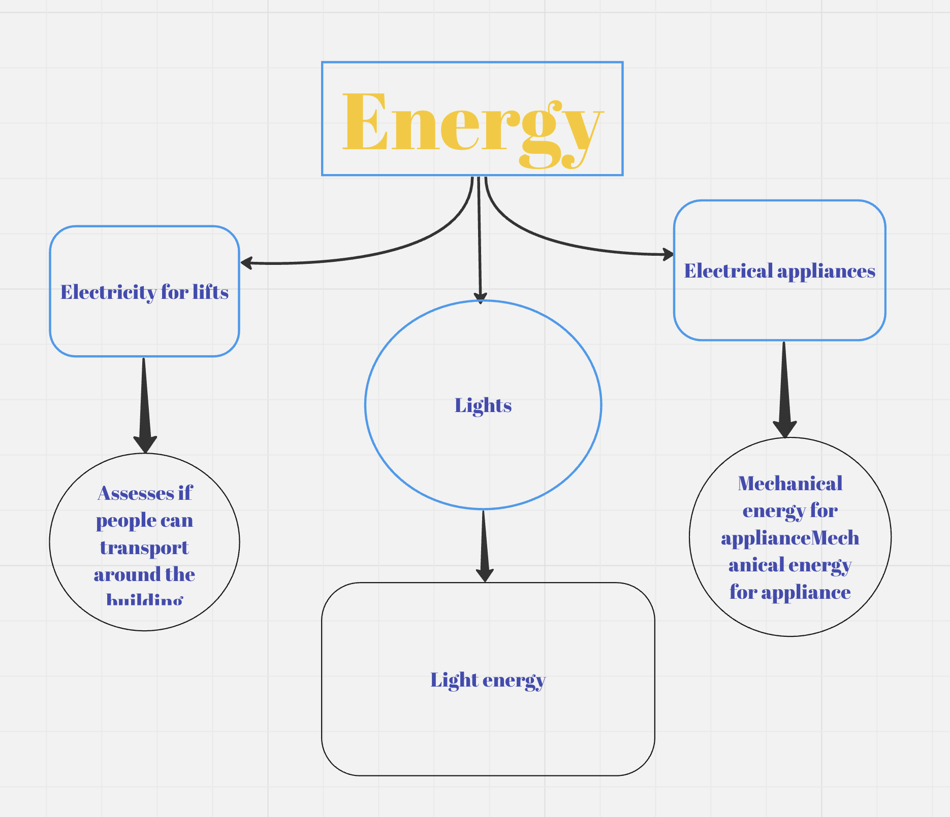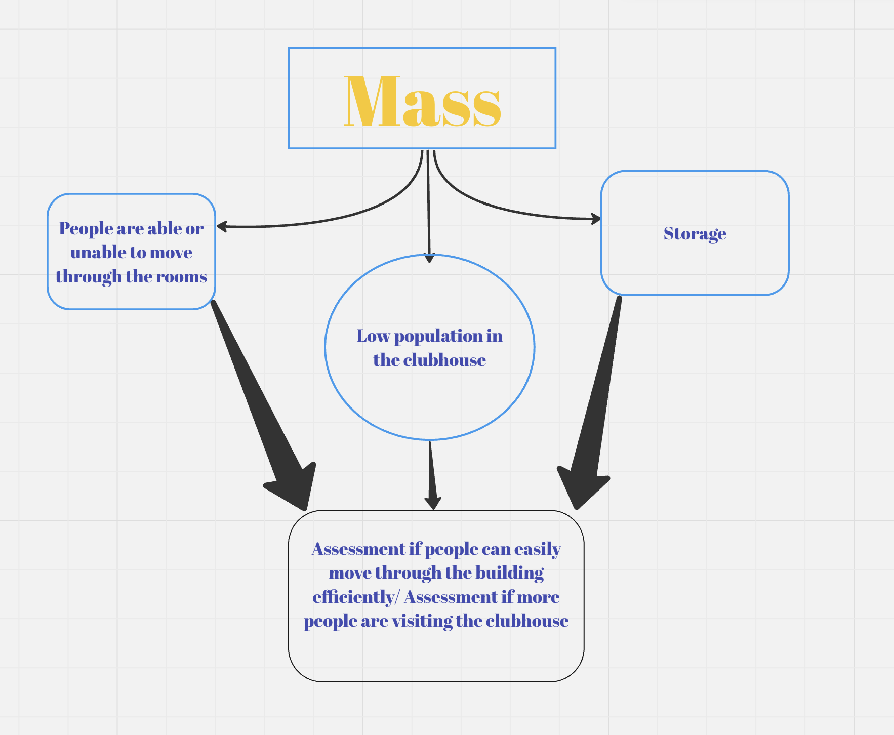

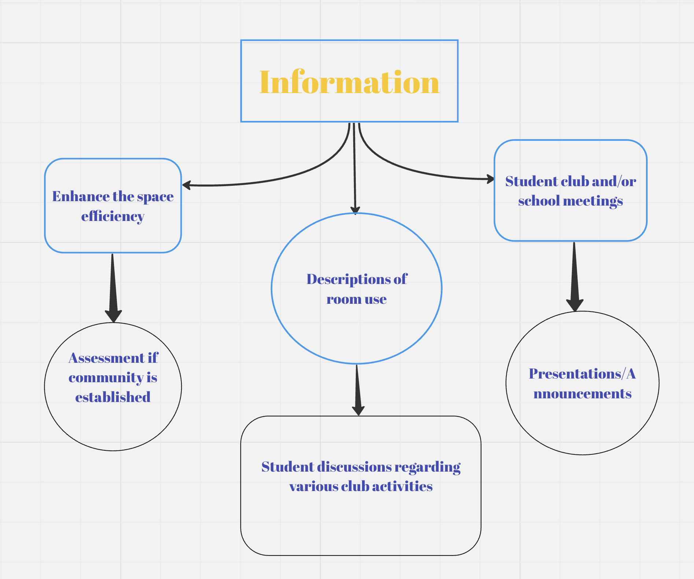

Figure 6. *FlowChart displaying the functions of the clubhouse*

6.0.0 Objectives

This section describes the project’s storage and space objectives that will assess the design solutions. The objectives listed below have been put in a Pairwise comparison chart in Appendix E to rank their importance. The project contains many intricacies related to each club and its requirements allowing for a wide range of objectives, metrics, and goals.

Table 4. *Space* *Objectives of the Sussex Clubhouse Project*

|  |  |  |
| --- | --- | --- |
| **Space Objectives** | Goals and Description | Metrics |
| Maximize utilization of space | The design should allow for clubs to get the most out of their space according to their needs [3].  This will help facilitate organized meetings and collaboration. | The design should allow for 1-6 or 7-20 students to share space comfortably with one another [5] as Ontario room codes vary depending on size. |
| Universal usage of furniture | The furniture should be easy to maneuver [10] and should create a unified workspace [11] rather than act as a hurdle within the space.  Furniture should add to the functionality and flexibility of the room. Clubs require the ability to move things according to how their needs align. [3] | The furniture should be able to withstand a minimum of one year of usage (the duration of most clubs) [3] before existing clubs leave and new clubs come in. |
| Durable and Robust | The design for each room should be maintainable with each club being able to clean and keep up with the design in their room.  [11]  Space designs need to be durable and robust when dealing with different types of materials, equipment, and people coming in and out of the Clubhouse. | The design should have a maintenance frequency of 1 year [3] and clubs should be able to maintain whatever they take ownership of as frequently as one month to annually (depending on usage of the room, etc) [12] |
| Minimize cost | The design should follow the budget requirements placed by the client [3].  The design should be selected to maintain the rest of the objectives as well as stay conscientious of the budget. | The budget for space solutions should be below $10,000 as outlined by the client. [3] |

Table 5: *Storage Objectives of the Sussex Clubhouse Project.*

|  |  |  |
| --- | --- | --- |
| **Storage Objectives** | Goals and Description | Metrics |
| Durable and Robust | Storage should withstand a range of heavyweight equipment and materials to lightweight materials.  [3]  There are many different types of clubs with a wide variety of storage needs [3]. | The frequency of storage items being damaged due to poor storage can be tracked every month for a year.[3] The goal is a low incidental rate every year [13]. |
| Secure | Storage should be able to hold and secure sensitive club items that only club leaders have access to.  [3]  This is important as many clubs have personal equipment and expensive gear that require safe storage while they are out of the Clubhouse. | Security incident reports will track the number of incidents per month related to security. [14] We aim for 0 incidents a month from each club [3]. |
| Flexible | Storage should be easily adjusted and configured to suit what each distinct club needs to store. [3].  The storage must be flexible to account for the changing needs and requirements of each club. | Clubs should be able to reach a higher range of 22%-27% space utilization (as this is a warehouse standard, but we do not need to take into consideration workers and worker labour cost) [5] by calculating the total size of their storage, their inventory size, and the storage cube size.[5] |
| Minimize cost | The design should follow the budget requirements placed by the client [3].  The design should be selected and built to maintain the rest of the objectives as well as staying conscientious of the budget. | The budget for storage solutions should be below $10,000 as outlined by the client. [3] |

7.0.0 Constraints

This section sets strict limits or boundaries for the design. The design must not exceed the constraints of the project.

Table 6. *Constraints of the Sussex Clubhouse project*

|  |  |
| --- | --- |
| Constraints | Metrics |
| Must not continue renovations after the allotted time frame. | Renovations must be completed within 2 weeks in June, as per the request of the client [16]. |
| Must not reach a maximum capacity of 20 people. | Metric of a maximum capacity of 20 people in the largest room of 22.21 m2 [5]. Appendix H contains the dimensions for the largest room. |
| Must not deconstruct room confinements (doors, windows, ceiling, walls), as there is asbestos in the walls. | Due to the hazards, 0 deconstructions should occur [16]. |
| Must not conflict with room designs initiated by the club. | 0 items should be removed without the club's permission [3]. |

8.0.0 Conclusion

The primary objective of this project is to maximize the space efficiency within the Sussex Clubhouse, ensuring optimal use of available areas for club activities while also providing better storage for the clubs considering the constraints of space and occupancy. A key focus is on integrating multifunctional designs that not only serve practical purposes but also foster an engaging environment. The team aims to design a more lively community in the clubhouse, modeling the pre-pandemic environment of school life.

9.0.0 Citations

[1] "Contact Us." St. George Campus Safety. <https://www.campussafety.utoronto.ca/contact-us> (Accessed Feb. 29, 2024).

[2] T. Cardoso. "Contact." The Varsity. <https://thevarsity.ca/contact/> (Accessed Feb. 29, 2024).

[3] A. Ahmed et al., “TUT0114 Team 095 First Client Meeting,” February 5, 2024

[4] "Sussex Court." Architectural Conservancy Ontario. <https://www.acotoronto.ca/building.php?ID=6617> (Accessed Feb. 28, 202

[5] Ontario Building Code, O Reg. 332/12 s.3.1.17(1)

[6] "Connect." Campus Wireless. <https://wireless.utoronto.ca/connect/> (Accessed Feb. 28, 2024)

[7] "Institutional Equity Office." University of Toronto. <https://people.utoronto.ca/inclusion/institutional-equity-office/> (Accessed Feb. 28, 2024).

[8] Toronto Municipal Codes Chapter 629 Property Standards, <https://www.toronto.ca/wp-content/uploads/2017/08/9027-1184_629.pdf> (accessed Feb 28, 2024).

[9] "Noise at Work." Environmental Health and Safety. <https://ehs.utoronto.ca/wp-content/uploads/2022/06/Noise-at-Work-Understanding-the-Difference-Between-Hazardous-and-Nuisance-Noise.pdf> (Accessed Feb. 28, 2024).

[10] Think Interior, “Furniture Arrangement: Strategies for Optimal Use of Space and Comfort,” Accessed: February 16, 2023. [Online]. Available: <https://academythinkinteriordesign.medium.com/furniture-arrangement-strategies-for-optimal-use-of-space-and-comfort-29b687cc5eca>

[11] "Universal Storage." Steelcase. <https://www.steelcase.com/products/systems-storage/universal-storage/> (Accessed Feb. 28, 2024).

[12] J. Bastian. "Revving Up Health & Safety in Schools Through Deep Cleaning." CloroxPro. <https://www.cloroxpro.com/blog/revving-up-health-safety-in-schools-through-deep-cleaning/> (Accessed Feb. 28, 2024).

[13] "Incident and Accident Reporting." Insurance Bureau of Canada. <https://www.ibc.ca/stay-protected/protect-your-business/incident-and-accident-reporting> (Accessed Feb. 28, 2024).

[14] "How to Report a Security Incident?" Shergroup. <https://shergroup.com/post/security-incident-reporting/#:~:text=A%20security%20incident%20report%20is,like%20theft%20and%20criminal%20attacks> (Accessed Feb. 28, 2024).

[15] "How to Calculate Warehouse Space Utilization." Camcode. <https://www.camcode.com/blog/how-to-calculate-warehouse-space-utilization/> (Accessed Feb. 28, 2024).

[16] Engineering Notebook Notes

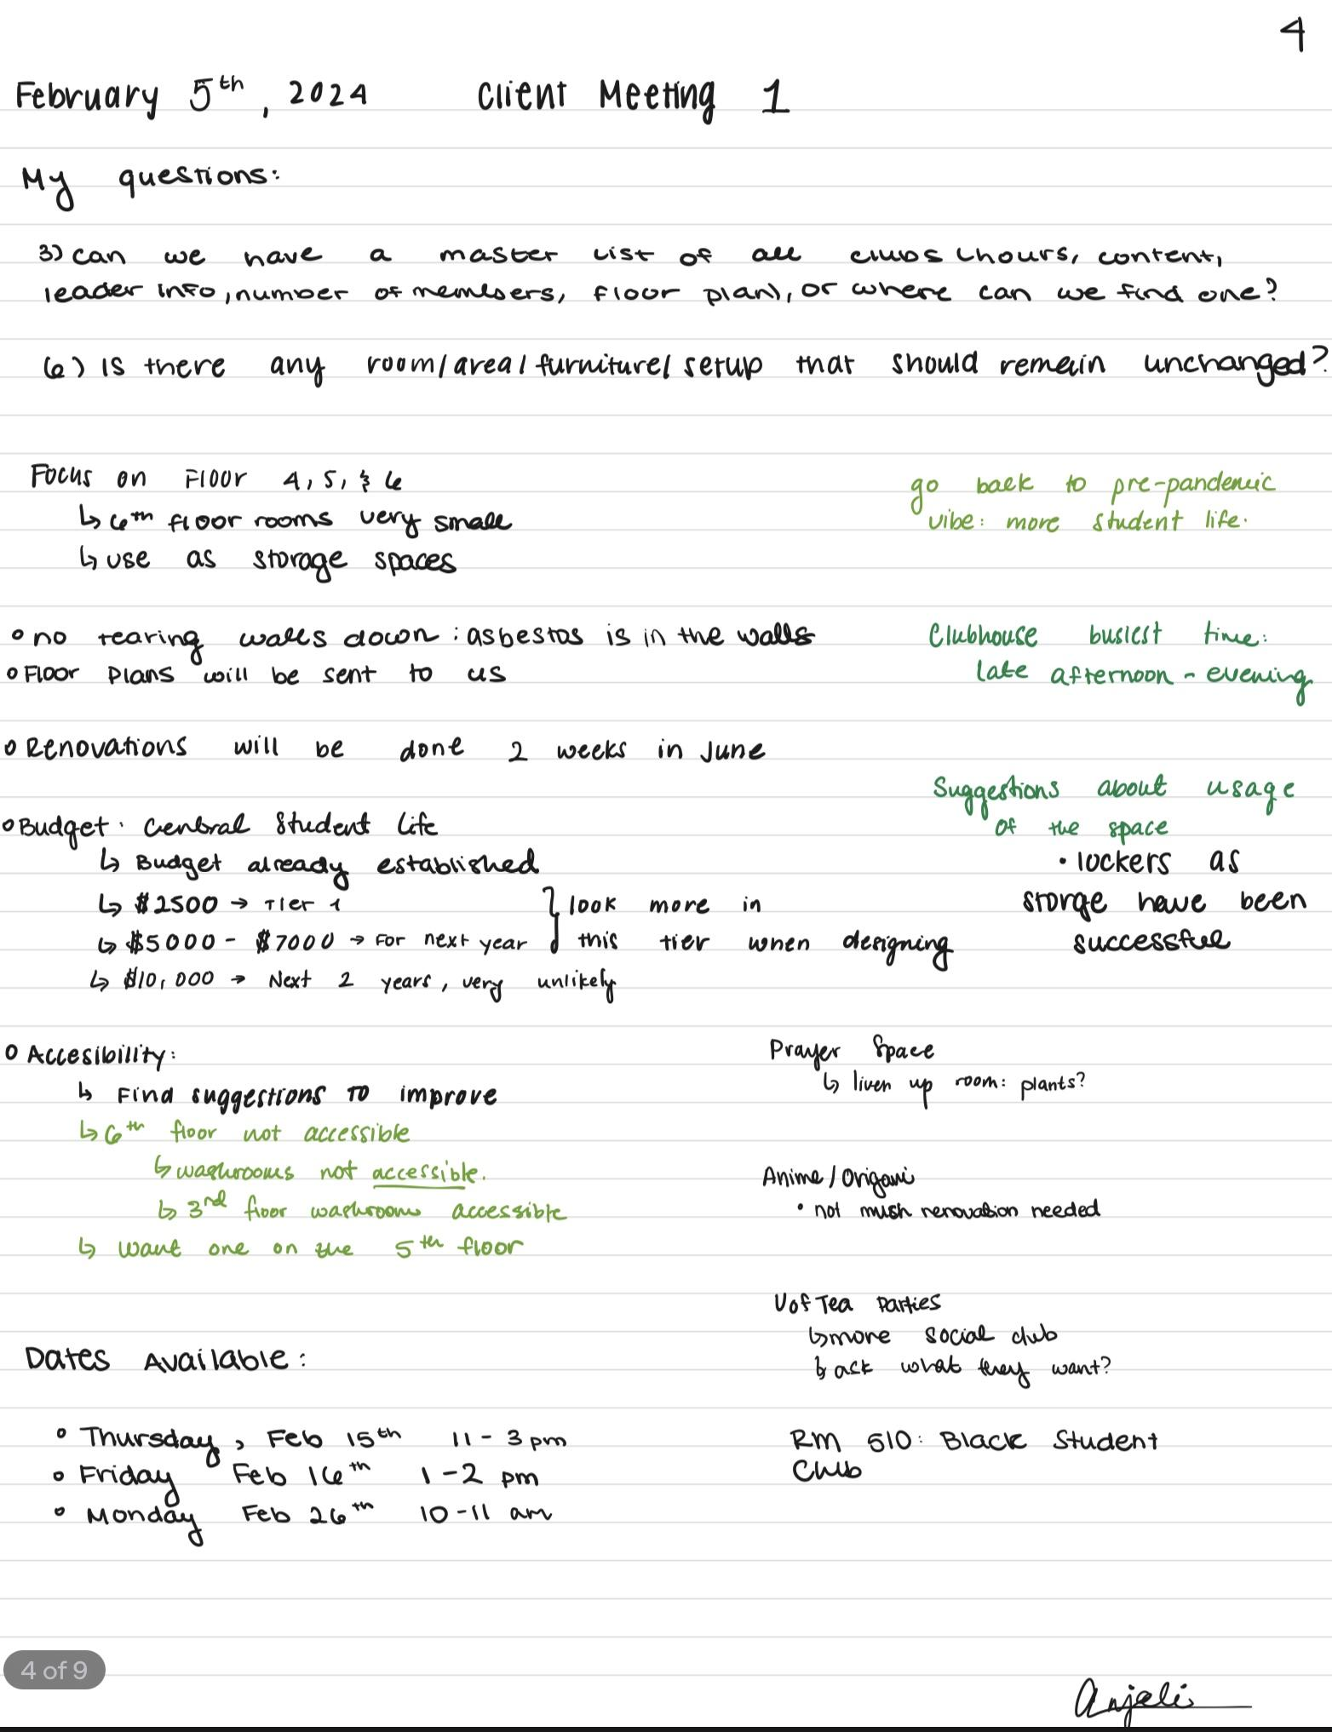

10.0.0 Appendix

# Appendix A. Functions

Appendix A outlines in detail of the Clubhouse utilization and the aspects that the design will contribute to.

Table 7. *Function descriptions*

|  |  |  |
| --- | --- | --- |
|  | Function | Description |
| Primary Functions | Provide free spaces for clubs. | The clubhouse was designed to create a community of clubs through the renovation of an old apartment building [3] to create a social environment for social activities and events. |
| Secondary Functions | Transport people around the clubhouse rooms. | The building contains dense rooms that don't allow students and staff to travel around their office. The design must improve this function as the client requires a better form of passage around the environment to move comfortably. |
| Brings more students into the clubhouse and constructs a more lively space. | The client believes that the clubhouse has had a large decrease (rooms that should contain 5-20 students now are mostly empty) in the number of students that go to the clubhouse after the pandemic [3]. Clubs have their meetings online which leaves the clubhouse emptier than what the client hopes. The design must improve this function by creating a space where students are more likely to have in-person meetings. |
| Provide a better storage system for clubs. | The client believes that the clubhouse has an inefficient storage system that can be optimized through a reassessment of storage placement. The design must attend to this function to keep the primary function of “Providing *free* spaces for clubs”. In other words, the storage must be optimized to create more space for clubs to run activities. |

# Appendix B. Objectives

Table 8. *Objective descriptions*

|  |  |
| --- | --- |
| Objective | Description |
| Maximize utilization of space | The design should allow for clubs to get the most out of their space according to their needs to facilitate organized meetings. The design should bring students in and give them a space to work and meet freely. The goal is to return to pre-pandemic numbers of the amount of students and liveliness within the Clubhouse. |
| Adaptable Furniture | Furniture should not be a hurdle in the room and something to overcome, it should add to the functionality and flexibility of the room. Specifically within the club setting, students need the ability to move around things according to how their needs align. Furniture can also serve more than one purpose to create more effective uses of the space (e.g. a table should have some storage component to it, chairs should be stackable, etc). |
| Durable and Robust | Storage and Space designs need to be durable and robust, especially when dealing with many different types of material, equipment, and people coming in and out of the Clubhouse. |
| Minimizes cost | During the Client meeting, the client set a 3-tier budget that they recommend based on 3-time levels:  Tier 1: Within next year $2 500  Tier 2: Within the next 5 years $5 000  Tier 3: In the future $10 000  Each of these tiers set how the budget for how long the design would last. Since our design is multifunctional and should be flexible for each club that occupies the room, this design should last the greatest duration possible. Therefore our maximum budget is $ 10,000. |
| Secure | Security measures are important to ensure a quality of safety within the clubhouse. It can allow students to feel as though they are able to leave their club valuables safely unattended to. This is also important as many clubs have personal equipment and expensive gear and tools that require safe storage. |
| Flexible | The storage within the rooms must be able to adapt to certain needs of certain clubs and be used for multiple types of materials and equipment. The storage must be flexible to account for the changing needs of the club. |

# 

# Appendix C. Constraints

Table 9*. Constraint descriptions*

|  |  |
| --- | --- |
| Constraint | Description |
| Must not continue renovations after the allotted time frame.. | Our client gave us a timeline of when the renovations should be completed. The 2-week timeframe in June is after the existing clubs will pack up their materials and before the incoming clubs will bring their materials. |
| Must not reach a ml./aximum capacity of 20 people. | According to the floor plans and measurements taken at the site, the largest room is 22.21 square meters. According to the Ontario Building Code [8], this room can fit a maximum of 20 people.  This is the math for the largest room however, the maximum capacity for each room will vary from room to room. |
| Must not deconstruct room confinements (doors, windows, ceiling, walls) | Nothing can be torn down due to the asbestos in the walls. |
| Must not conflict with room designs initiated by the club. | Certain clubs have brought in their equipment such as televisions, couches, and storage units. We must not remove these materials. |

# 

# 

# 

# Appendix D. List of Clubhouse Contact List

Table 10: *Clubhouse Contact List*

|  |  |  |  |  |  |  |
| --- | --- | --- | --- | --- | --- | --- |
| **RM.** | **GROUP NAME** | **PRIMARY** | **ADMIN 1** | **ADMIN 2** | **PUBLIC EMAIL** | **NOTES** |
| 315 | Intern Lounge |  |  |  |  |  |
| 316 | Campus Life Resource Lounge and Library |  |  |  |  |  |
| 317 | Campus Life Resource Lounge and Library |  |  |  |  |  |
| 318 | Adonica Huggins, Coordinator, Academic and Peer Programs |  |  |  |  |  |
| 321 | Student Engagement Staff Meeting Room |  |  |  |  |  |
| 322 | Imani King, Administrative Coordinator |  |  |  |  |  |
| 323 | Adam Kuhn, Director, Student Engagement |  |  |  |  |  |
| 325 | Jennifer Barcelona, Assistant Director, Student Engagement |  |  |  |  |  |
| 326 | Madi Frost, Lead Coordinator, Mentorship & Peer Programs |  |  |  |  |  |
| 327 | Modele Kuforiji, Cooridnator, Black Student Engagement |  |  |  |  |  |
| 403 | Armenian Students' Association of the University of Toronto | ani.khachatrian@mail.utoronto.ca | britt.cheng@mail.utoronto.ca |  | asa.utoronto@gmail.com |  |
| 403 | Visual Art Club | sissi.zhu@mail.utoronto.ca | mayling.pon@mail.utoronto.ca |  | utvisualartclub@gmail.com |  |
| 404 | Black Doctors of Tomorrow | m.blaise@mail.utoronto.ca | nawal.olanrewaju@utoronto.ca | ella.nugent@mail.utoronto.ca | blackdot.cos@gmail.com |  |
| 404 | University College Dragon Boat Club | jasonyiyang.yang@mail.utoronto.ca | eric.waszak@mail.utoronto.ca | larissa.pringle@mail.utoronto.ca | ucdragonboat@gmail.com |  |
| 406 | Bookable Rehearsal Room |  |  |  |  |  |
| 409 | Canadian Politics Club | fadeel.sheikh@mail.utoronto.ca | teaghen.schneider@mail.utoronto.ca |  | uoftcanpol@gmail.com |  |
| 409 | Organization of Latin American Students | [Removed] | helen.batchoun@mail.utoronto.ca |  | olassg@studentorg.utoronto.ca |  |
| 410 | Afro-Dance and Culture Club | christopher.prempeh@mail.utoronto.ca | sarah.nkoutasen@mail.utoronto.ca |  | adc.uoft@gmail.com |  |
| 410 | Women’s Health Collective | ariel.orozco@mail.utoronto.ca | joy.yin@mail.utoronto.ca |  | whcuoft@gmail.com |  |
| 411 | Chinese Christian Fellowship | jenniferrui.zhang@mail.utoronto.ca | marc.yip@mail.utoronto.ca |  | utccfcommittee@gmail.com |  |
| 411 | Silhouettes Dance Company | heather.gadalla@mail.utoronto.ca | henry.lewis@mail.utoronto.ca |  | silhouettesdance@gmail.com |  |
| 412 | Peace by PEACE | [Removed] | Lyjason.qian@mail.utoronto.ca |  | campusdirector.uoft@peacebypeace.ca |  |
| 412 | University of Toronto Portuguese Association | l.antunes@mail.utoronto.ca | matthew.araujo@mail.utoronto.ca |  | utpa_club@yahoo.com | Prefer personal email: lcantunespt@gmail.com , mattaraujo425@gmail.com |
| 415 | Bookable Meeting Room |  |  |  |  |  |
| 416 | Sexual Gender and Diversity Office |  |  |  |  |  |
| 417 | Sexual Gender and Diversity Office |  |  |  |  |  |
| 418 | University of Toronto Economics Club (ECON) | nicolas.martinezgonzalez@mail.utoronto.ca | [Removed] |  | econuoft@gmail.com |  |
| 418 | UofTea Party | matthewuoft.yang@mail.utoronto.ca |  |  | uofteaparty@gmail.com |  |
| 419 | Communal Kitchenette |  |  |  |  |  |
| 421 | Jim Delaney Lounge |  |  |  |  |  |
| 422 | ACE UTSG | harvi.karatha@mail.utoronto.ca | sarry.zhong@mail.utoronto.ca |  | aceutsg@gmail.com |  |
| 422 | University of Toronto Outing Club (UTOC) | talia.yawney@mail.utoronto.ca | zach.groves@mail.utoronto.ca | amy.baggs@mail.utoronto.ca | secretary@utoc.ca |  |
| 423 | Greek Students' Association | a.koutlemanis@mail.utoronto.ca | melina.lavasidis@mail.utoronto.ca |  | uoft.greeks@gmail.com |  |
| 423 | Middle Eastern Students' Association (MESA) | zinah.qadoumi@mail.utoronto.ca | jana.khatib@mail.utoronto.ca |  | mesa.utsg@gmail.com |  |
| 425 | Only Human Dance Collective | nasya.sequeira@mail.utoronto.ca | anne.qian@mail.utoronto.ca |  | ohdc.admin@gmail.com |  |
| 425 | UT Viewfinder photography club | xinyuem.wang@mail.utoronto.ca | mana.deng@mail.utoronto.ca | zhiyue.li@mail.utoronto.ca | ut.viewfinder@gmail.com |  |
| 426 | Black Graduate Students' Association | jolomi.tosanwumi@mail.utoronto.ca | isdora.msigwa@mail.utoronto.ca |  | bgsa@studentorg.utoronto.ca |  |
| 426 | UTSG Bhangra Club | gurneha.singh@mail.utoronto.ca | kiara.sankhe@mail.utoronto.ca | sukh.thukral@mail.utoronto.ca | utsgbhangra@gmail.com |  |
| 427 | Myanmar Culture Club | napas.thein@mail.utoronto.ca | suzan.yehtwe@mail.utoronto.ca | natalie.frigon@mail.utoronto.ca | uoft.myanmar@gmail.com |  |
| 427 | UTSG Tamil Students' Association | [Removed] | bairavi.arulanantham@mail.utoronto.ca | ansia.sivakumaran@mail.utoronto.ca | contact@utsgtsa.com |  |
| 503 | Bookable Meeting Room |  |  |  |  |  |
| 505 | Muslim Students' Association (MSA) | [Removed] | [Removed] |  | execs@uoftmsa.com |  |
| 505 | Taiwan Republic of China Student Association at the University of Toronto (ROCSAUT) | sally.tsai@mail.utoronto.ca | kaiyu.liu@mail.utoronto.ca | Iris.chen@mail.utoronto.ca | uoftrocsaut@gmail.com |  |
| 507 | Undergraduate Research Students' Association | d.nazarkina@mail.utoronto.ca | daphne.jiang@mail.utoronto.ca |  | uoftursa@gmail.com |  |
| 507 | Women in Computer Science | ananya.jain@mail.utoronto.ca | kirsten.sutantyo@mail.utoronto.ca |  | wicsuoft@gmail.com |  |
| 503 | Multi-Faith Worship & Meditation Room |  |  |  |  |  |
| 515 | Ryan Kavanagh, Officer, Recognized Campus Organizations |  |  |  |  |  |
| 515 | Alyssa Ahmed, Coordinator, Recognized Campus Organizations |  |  |  |  |  |
| 526 | Astronomy and Space Exploration Association | affan.khadir@mail.utoronto.ca | harlin.toor@mail.utoronto.ca |  | space.association.utasx@gmail.com |  |
| 526 | Veg Club | lingling.deng@mail.utoronto.ca | ahmar.sami@mail.utoronto.ca | samantha.macklin@mail.utoronto.ca | utorvegclub@gmail.com |  |
| 527 | University of Toronto eSports Club | marco.mai@mail.utoronto.ca | anisa.dahir@mail.utoronto.ca | Kirsten.sutantyo@mail.utoronto.ca | uoft.esports@gmail.com |  |
| 527 | University of Toronto Minecraft Club (UTMC) | frannie.favot@mail.utoronto.ca | sebin.im@mail.utoronto.ca |  | uoftminecraft@gmail.com |  |
| 529 | Inclusive Communities Canada – U of T Student Chapter (ICCan UofT) | celine.safati@mail.utoronto.ca | sydney.sharp@mail.utoronto.ca |  | uoft@inclusivecommunitiescanada.org |  |
| 529 | Indian Students' Organization | Akshita.Bharti@mail.utoronto.ca | ahmad.ashraf@mail.utoronto.ca | aliza.mithwani@mail.utoronto.ca | issutsg@gmail.com |  |
| 531 | Anime and Manga Association | anastasia.radisic@mail.utoronto.ca | jeho.cho@mail.utoronto.ca |  | utama.website@gmail.com |  |
| 531 | Fly with Origami, Learn to Dream (UTFOLD) | lucyhe.zhou@mail.utoronto.ca | ira.nagpal@mail.utoronto.ca |  | ut.fold@gmail.com |  |
| 532 | Afghan Students' Association | y.jamasi@mail.utoronto.ca | You |  | afghansauoft@gmail.com |  |
| 532 | University of Toronto Indonesian Student Association (UTISA) | agnes.santoso@mail.utoronto.ca | annette.chandra@mail.utoronto.ca | hanif.noegroho@mail.utoronto.ca | utisa.utoronto@gmail.com |  |
| 534 | Friends of Médecins Sans Frontières (Doctors Without Borders) – University of Toronto Student Chapter | mahhik.butt@mail.utoronto.ca | yyoojin.lee@mail.utoronto.ca |  | msf.friends.uoftoronto@gmail.com |  |
| 534 | UTChinese Network | jason.pu@mail.utoronto.ca | ellazhang.zhang@mail.utoronto.ca | shelley.xue@mail.utoronto.ca | mail@utchinese.org |  |
| 535 | Secondary School Interactive Crisis Simulation (SSICSIM) | sharan.vaidyanathan@mail.utoronto.ca | aidanm.thompson@mail.utoronto.ca |  | contact@ssicsim.ca |  |
| 535 | UTMUN | [Removed] | sharan.vaidyanathan@mail.utoronto.ca |  | sg@utmun.org |  |
| 536 | Healthy Minds | [Removed] | catherine.chi@mail.utoronto.ca |  | healthymindsut@gmail.com |  |
| 536 | The Mindful Project | delphine.li@mail.utoronto.ca | chris.arrabito@mail.utoronto.ca |  | uoftthemindfulproject@gmail.com |  |
| 604 | University of Toronto Japan Association | masayo.takao@mail.utoronto.ca | kento.takeda@mail.utoronto.ca | yif.sun@mail.utoronto.ca | uoft.japan.association@gmail.com |  |
| 605 | University of Toronto Emergency First Responders | jerhhao.han@mail.utoronto.ca | howell.fang@mail.utoronto.ca |  | info@utefr.ca |  |
| 606 | Leukemia and Lymphoma Chapter (LLC) | bennn.shaw@mail.utoronto.ca | gerd.bizi@mail.utoronto.ca |  | leukemiauoft@gmail.com |  |
| 607 | Students’ Alzheimer’s Alliance at U of T | clara.rivayasalvadores@mail.utoronto.ca | rosa.burke@mail.utoronto.ca |  | alzheimeruoft@gmail.com |  |
| 608 | Socialist Fightback Students | d.golden@mail.utoronto.ca | finn.ngo@mail.utoronto.ca |  | sfsuoft@gmail.com |  |
| 609 | Rational Capital Investment Fund | shayan.siddiqui@mail.utoronto.ca | mattw.wang@mail.utoronto.ca | caroline.bissonette@mail.utoronto.ca | rational.capital@studentorg.utoronto.ca |  |
| 610 | Academic Trivia Club | sky.li@mail.utoronto.ca | jny.chow@mail.utoronto.ca |  | uoftquizbowl@gmail.com |  |
| 612 | Jesse Adigwe, Coordinator, Campus Involvement |  |  |  |  |  |
| 612B | Jennifer Pinker, Coordinator, Graduate Programs and Outreach |  |  |  |  |  |
| 612C | Trent Barwick, Lead Coordinator, Orientation, Transition & Engagement |  |  |  |  |  |
|  |  |  |  |  |  |  |
|  |  |  |  |  |  |  |
|  | GREY = PUBLIC SPACE |  |  |  |  |  |
|  | YELLOW = POTENTIAL OFFICE SPACE NOT OCCUPIED |  |  |  |  |  |
|  | RED = NEEDS TO BE UPDATED |  |  |  |  |  |
|  | GREEN = NO CHANGES OR BEEN FIXED |  |  |  |  |  |
|  | BLUE = OFFICE SPACE |  |  |  |  |  |
| Updated: | August 3rd, 2023 |  |  |  |  |  |

# 

# Appendix E. Objective Pairwise Comparison Chart

Appendix E showcases a pairwise comparison chart between each objective to rank each objective by importance.

Table 11. *Space Objective Pairwise Comparison Chart*

|  |  |  |  |  |  |
| --- | --- | --- | --- | --- | --- |
|  | Maximize utilization of space | Adaptable Furniture | Minimize cost | Durable and robust | Total |
| Maximize utilization of space |  | 1 | 1 | 1 | 3 |
| Adaptable Furniture | 0 |  | 1 | 1 | 2 |
| Minimize cost | 0 | 0 |  | 0 | 0 |
| Durable and robust | 0 | 0 | 1 |  | 1 |

Table 12*: Storage Objectives Pairwise Comparison Chart*

|  |  |  |  |  |  |
| --- | --- | --- | --- | --- | --- |
|  | Flexible | Secure | Minimize cost | Durable and robust | Total |
| Flexible |  | 0 | 1 | 0 | 1 |
| Secure | 1 |  | 1 | 0 | 2 |
| Minimize cost | 0 | 0 |  | 0 | 0 |
| Durable and robust | 1 | 1 | 1 |  | 3 |

# 

# Appendix F 4th, 5th, and 6th Floor Plans and Some Room Dimensions

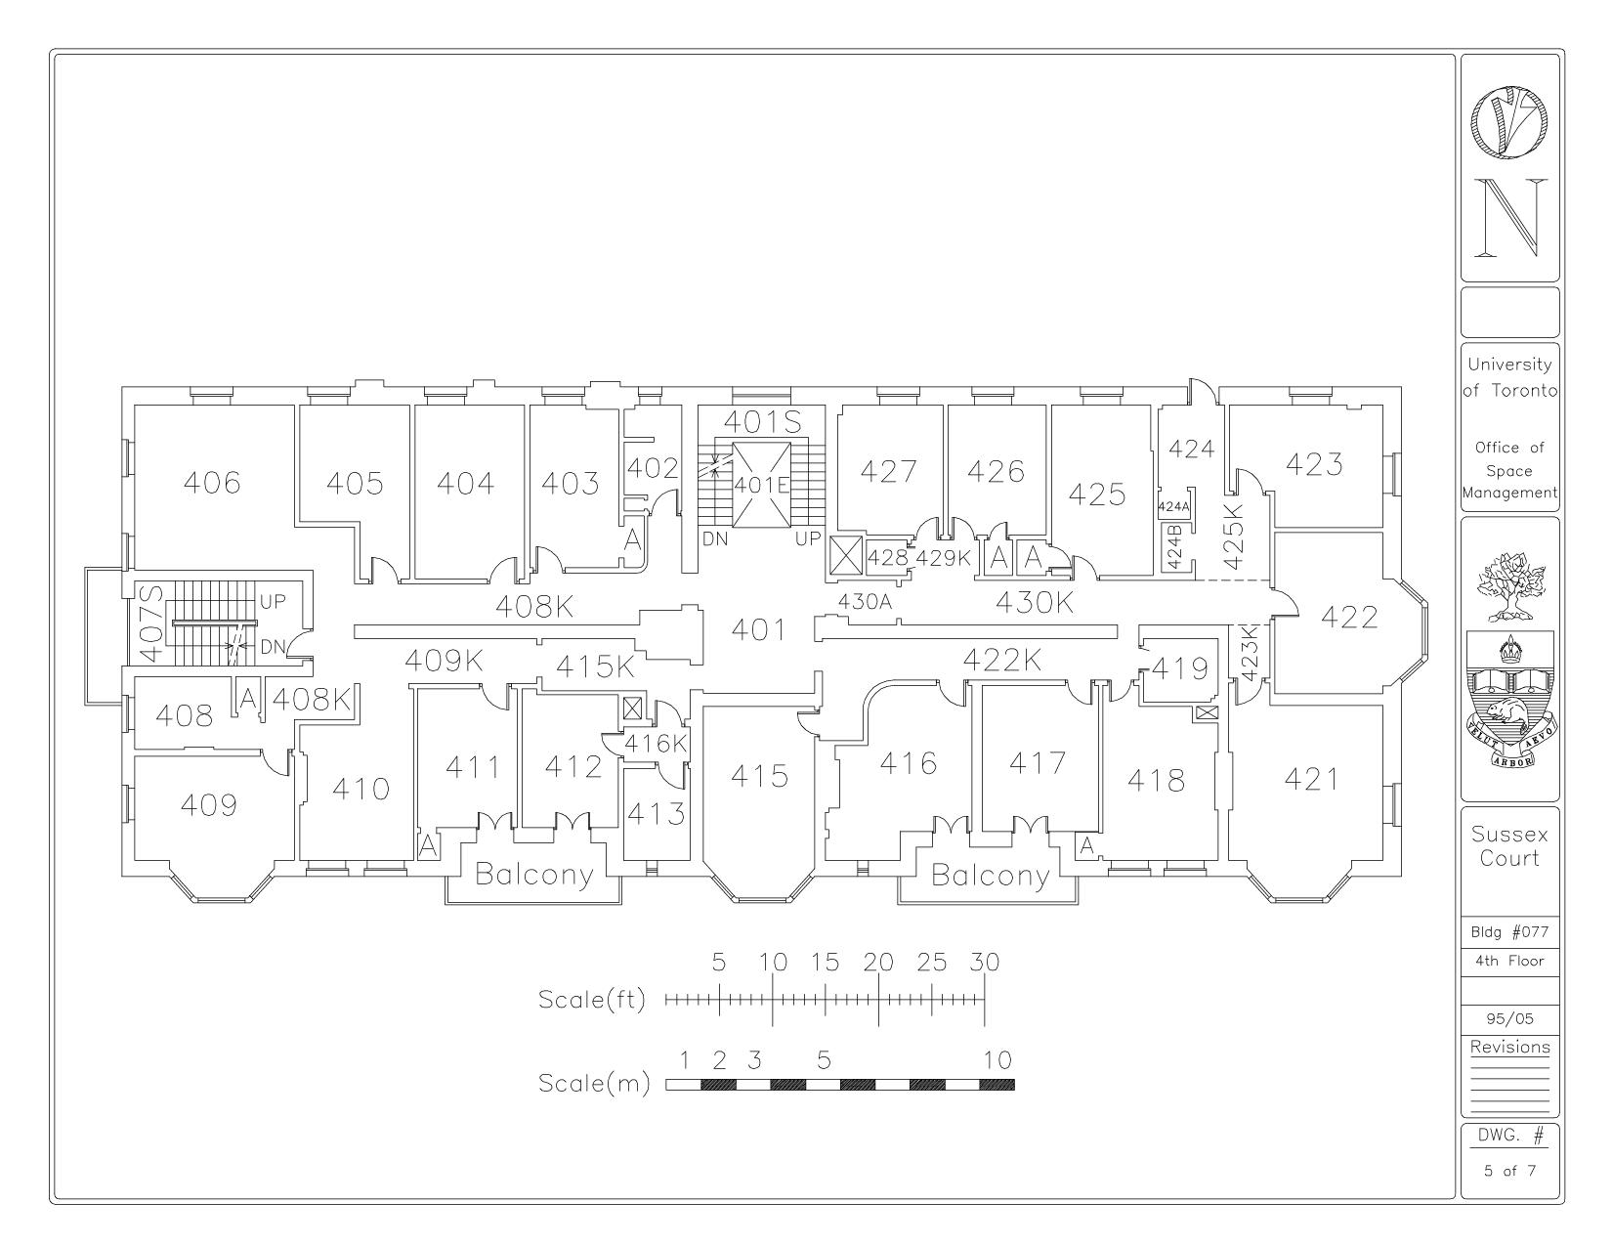

Figure 6: *4th Floor Plan*

Figure 7: *5th Floor Plan*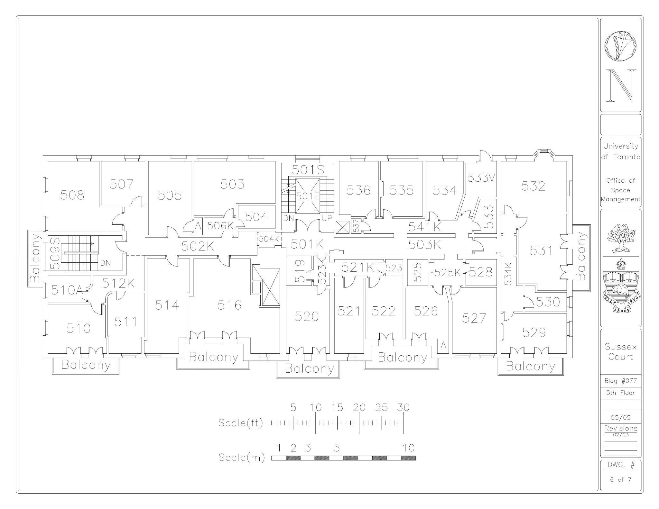

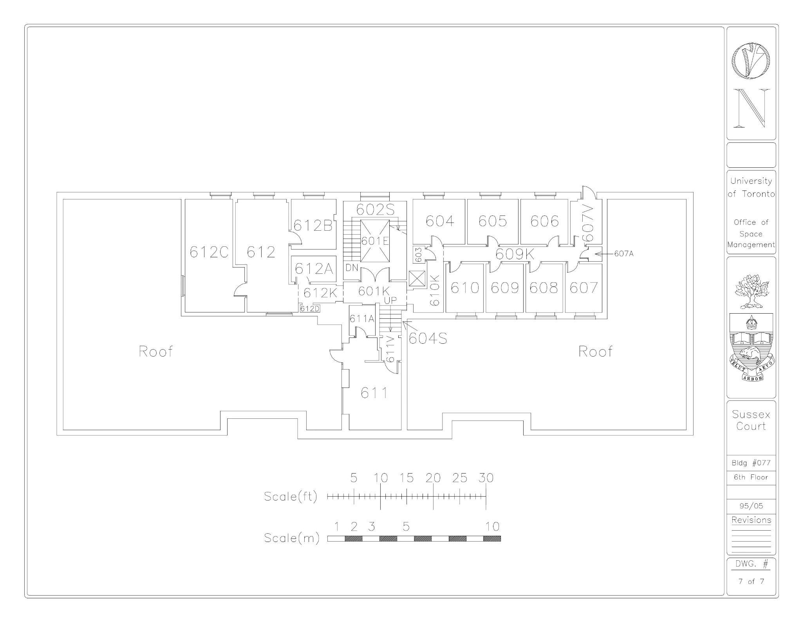

Figure 8. *6th Floor Plan*

# Appendix G Black Box Method: Functions

This section outlines the methods employed to derive the design functions. The "inputs" are put through a black box analysis of our design to observe the "outputs".

Table 13. *Black Box Method Analysis of the clubhouse*

| Inputs | → Design → | Outputs |
| --- | --- | --- |
| **Mass** | **Mass** |
| * People are able or unable to travel through the rooms in the building * Low population in the clubhouse * Storage | * Assessment if people can easily move through the rooms within the building efficiently * Assessment if more people are visiting the clubhouse (floors 4,5, and 6) |
| **Energy** | **Energy** |
| * Electricity for lifts * Lights * Electrical appliances. | * Assesses if people can transport around the building * Mechanical energy for appliances * Light energy |
| **Information** | **Information** |
| * Enhance the space efficiency within rooms on the 4th, 5th and 6th floors. * Descriptions of room use * Student club and/or school meetings | * Assessment if community is established * Student discussions regarding various club activities * Presentations * Announcements |

# Appendix H. Measurements and Area calculations

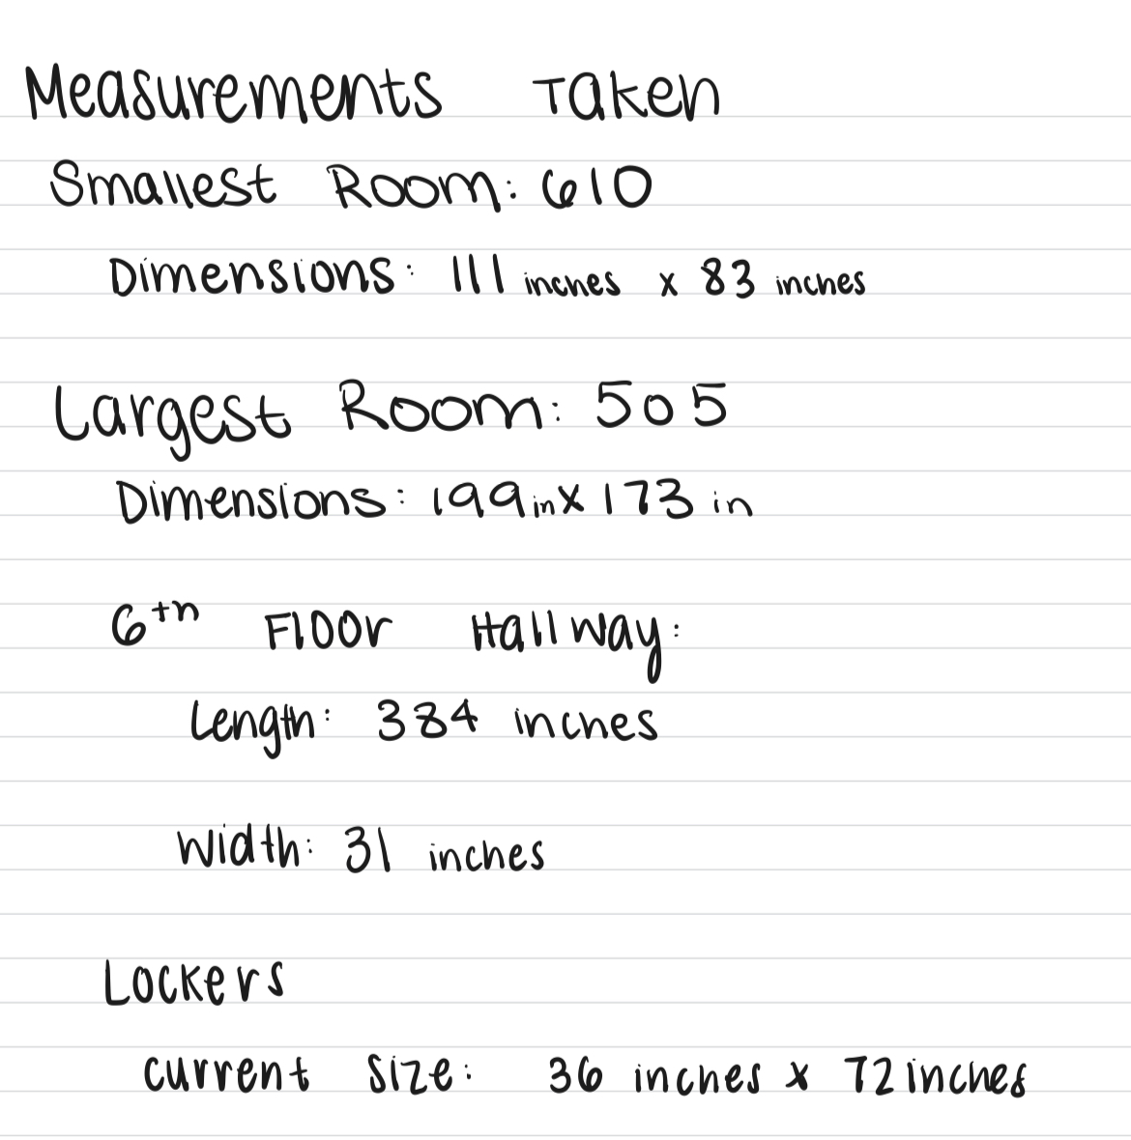

Figure 10. *Measurements and area calculations taken of rooms*

**Appendix I. Service Environment (Virtual Environment)**

Figure 11. *The U of T wifi connection in Mbps at Clubhouse meeting room*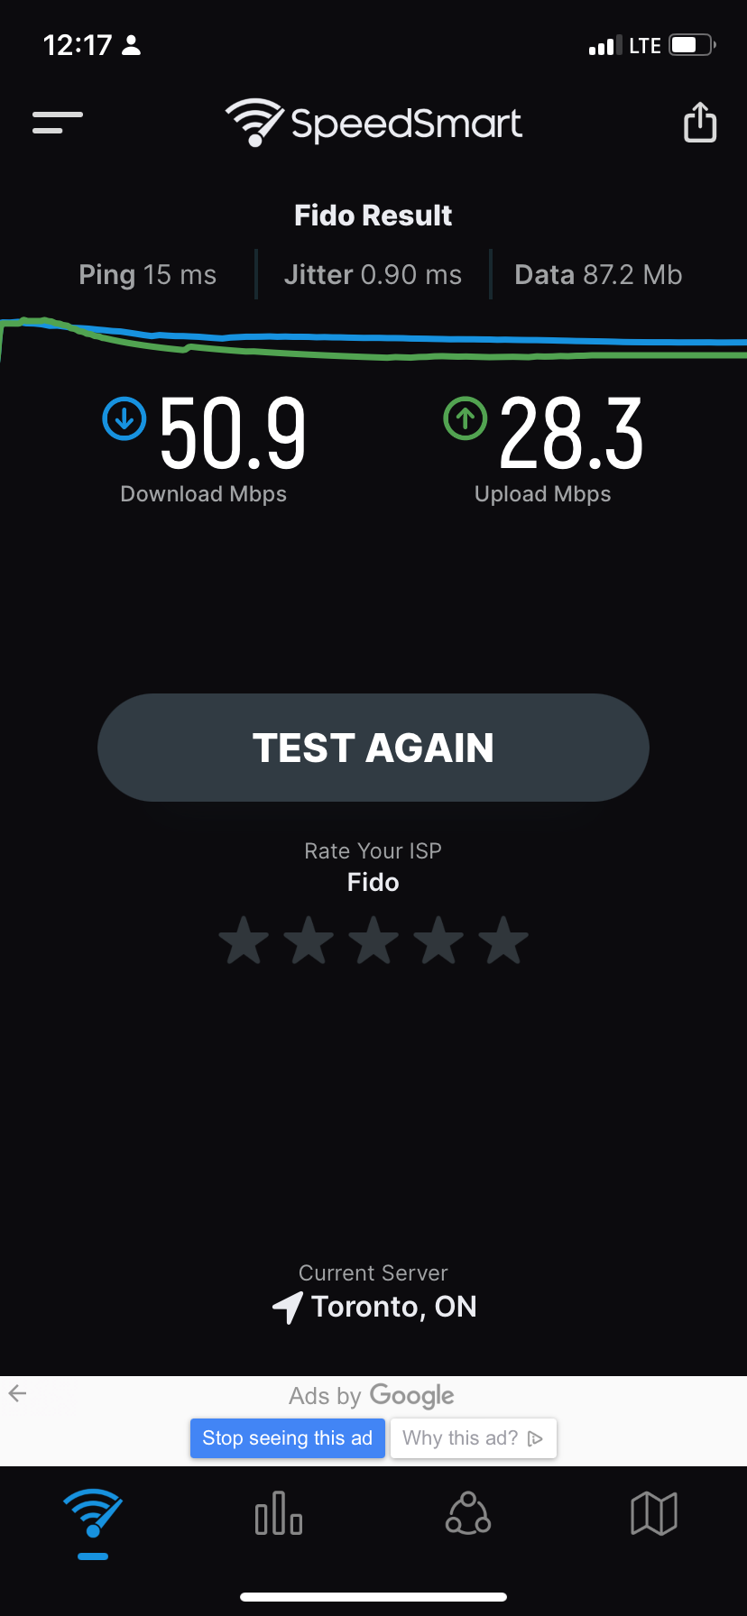

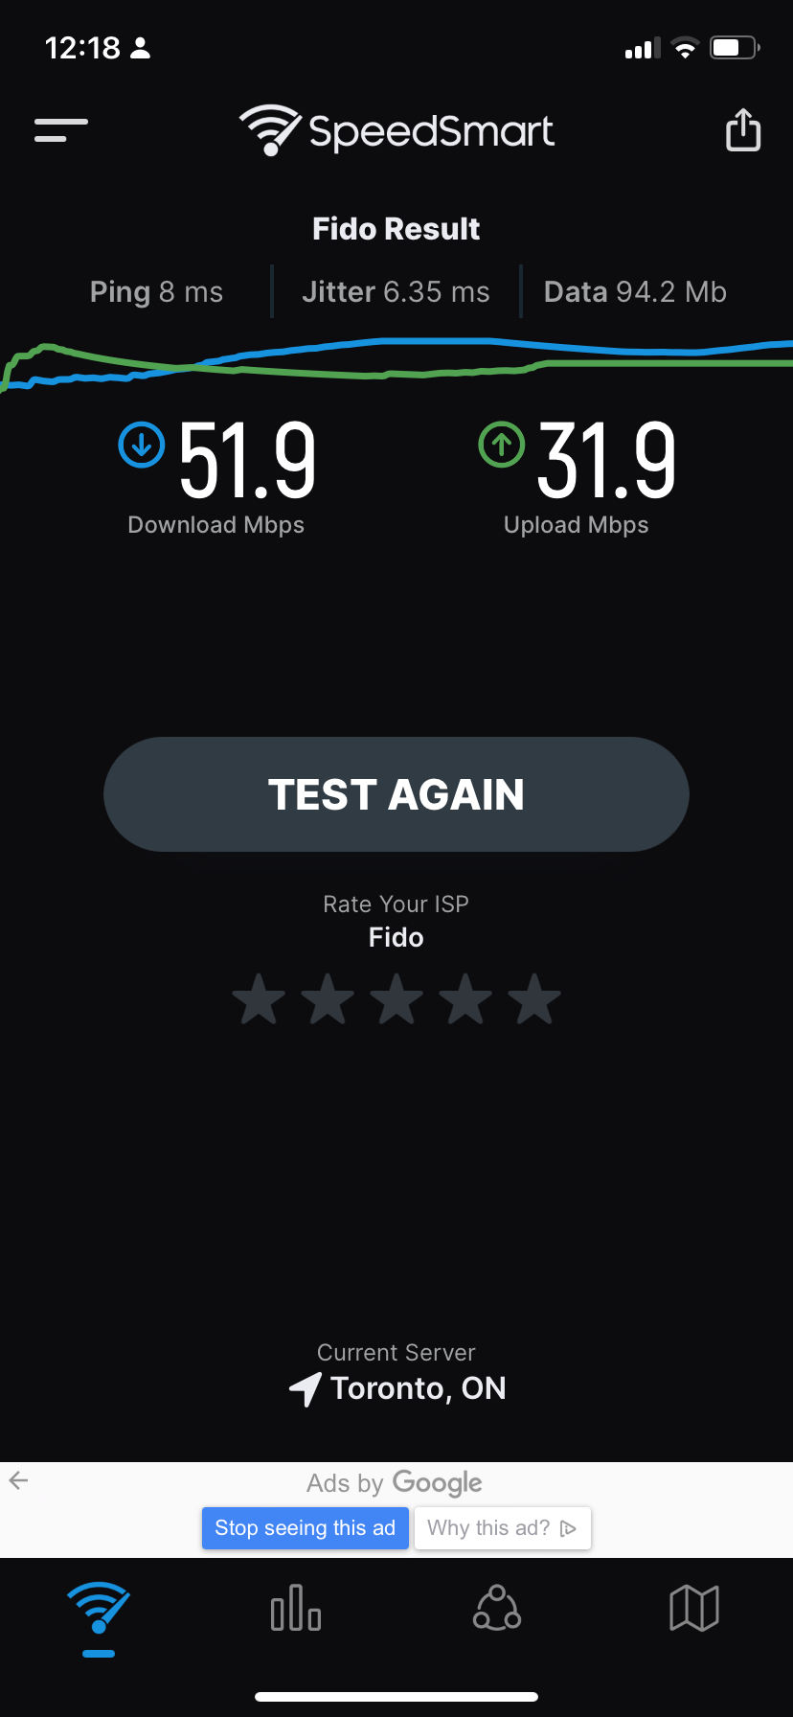

Figure 12. *Data connection in Mbps at Clubhouse meeting room*

|  |  |  |  |
| --- | --- | --- | --- |
| Tutorial #: | TUT-0114 | Team #: | 095 |
| Assignment: | Preliminary Requirements | Date: | Feb 16th, 2023 |

The Attribution Table is a major resource used by your TA in determining whether there was an equal contribution to the team assignment. If your TA determines that there was a significant under-contribution, then they may apply an individual penalty to the under-contributing team members’ grades. As a future professional engineer, you should NOT sign any document you have not read and do not agree with.

The Attribution Table must be completed, signed by all team members, and included as an appendix of your assignment AND uploaded to your MS Teams team channel. Teams who do not submit a completed form, including those who submit an incomplete form, such as one missing a team member’s signature, will receive a zero on the assignment. The team may submit a petition to the ESP Office if they feel the lack of signature is through no fault of the team.

The Attribution Table should accurately reflect each team member’s contribution to the document. Be sure to keep a copy of this form for the team’s records.

If there are irreconcilable differences that are preventing all team members from signing the attribution table then each team member must write a letter (<one page) explaining their position on the difference and suggest a solution. These letters must be submitted to the TA.

As with any engineering statement, this attribution table must be backed by credible evidence. In most cases, this will be found either in the Google Docs document revision history or in your engineering notebook. Making fraudulent claims in an Attribution Table displays intent to deceive and is a serious academic offence.

|  |  |  |  |  |  |  |
| --- | --- | --- | --- | --- | --- | --- |
| Section | Student Names: Anjali Jammulamadaka, Chris Yip, Dora Lyu, Lydia Messiha, Matthew Ting, Margaret Chen | | | | | |
| Anjali | Chris | Dora | Lydia | Matthew | Margaret |
| Executive Summary |  | ET | ET WD | ET, WD, MR, FP | WD MR FP | WD ET |
| 1.0.0 Introductions |  |  | ET | WD, RS, MR,FP | WD MR FP | ET |
| 2.0.0 Problem Statement | ET | WD, ET, RS | ET | WD, RS, MR, ET,FP | MR FP | ET |
| 3.0.0 Service Environment | ET, MR, FP, RS2 | OR5, RS2 | ET | RS2,FP | WD MR FP | RS2 ET WD MR |
| 4.0.0 Stakeholders | ET, FP |  | RS3 ET WD | RS,FP | WD MR FP | ET |
| 5.0.0 Functions | FP | OR1, OR6, FP, MR | ET | ET,FP | WD MR FP | OR6 |
| 6.0.0 Objectives | FP | ET | ET | WD, RS, MR, ET,FP | WD MR RS1 FP | ET |
| 7.0.0 Constraints | WD, MR, OR3, FP |  | ET | ET,FP | WD MR RS1 FP | ET |
| 8.0.0 Conclusion | WD, ET, FP | ET | ET | ET,FP | MR FP | ET WD |
| 9.0.0 Citations | MR, FP |  | MR | WD,FP | MR FP | ET |

Fill in abbreviations for roles for each of the required content elements using the abbreviations found on the next page. You do not have to fill in every cell.

|  |  |
| --- | --- |
| RS – Research (give details below)  WD – Wrote Draft  MR – Major Revision  ET – Edited | FP – Final Proofread of COMPLETE DOCUMENT verifying for flow and consistency  OR – Other (give details below) |

If you put RS (research) please add a number identifier such as RS1, RS2, etc. Give the research question/topic:

|  |  |
| --- | --- |
| RS1: | Research on crowd density and furniture placement for objectives and constraints |
| RS2: | Measurements of the Clubhouse, dimensions of rooms, corridors, etc. |
| RS3: | Research on Stakeholder interest examples |

If you put OR (other) please add a number identifier such as OR1, OR2, etc. Explain the role below:

|  |  |
| --- | --- |
| OR1: | Create appendix A: Functions |
| OR2: | Create Appendix B: Objectives |

|  |  |
| --- | --- |
| OR3: | Create Appendix C: Constraints |

|  |  |
| --- | --- |
| OR4: | Create Appendix E: Objective Pairwise comparison |

|  |  |
| --- | --- |
| OR5: | Create Appendix I: Service environment (virtual environment) |

|  |  |
| --- | --- |
| OR6: | Create Appendix G: Black Box Method |

|  |  |
| --- | --- |
| OR  7: | Create |

By typing your name below to sign, you verify that you have:

* Read the attribution table and agree that it accurately reflects your contribution to the associated document.
* Written the sections of the document attributed to you and that they are entirely original.
* Accurately cited and referenced any ideas or expressions of ideas taken from other sources according to the standard specified by this course.
* Read the University of Toronto Code of Behaviour on Academic Matters and understand the definition of academic offence includes (but is not limited to) all forms of plagiarism. Additionally, you understand that if you provide another student with any part of your own or your team’s work, for whatever reason, and the student having received the work uses it to commit an academic offence, then you are considered an equal party in the offence and will be subject to academic sanctions.

|  |  |  |  |
| --- | --- | --- | --- |
| Student #1 Name | Dora Lyu | Student #5 Name | Lydia Messiha |
| Student #2 Name | Margaret Chen | Student #6 Name | Chris Yip |
| Student #3 Name | Anjali Jammulamadaka | Student #7 Name |  |
| Student #4 Name | Matthew Ting |  |  |
|  |  |  |  |